**Setting up Matlab**

For these labs you will need to use MATLAB and the Peter Corke robotics toolbox. To ensure compatibility, please ensure you are using:

* MATLAB 2019/2020
* Robotics Toolbox 10.4

**Installing Matlab**

* On the following page, under "a) Run Matlab on your own machine and/or online", click the Link to the TAH Portal: <https://www.comm.utoronto.ca/~bkf/comm/matlab.html>
* There you should be able to log in with your U of T credentials and download MATLAB. Please ensure that you download either MATLAB 2019 or 2020

**Installing the Robotics Toolbox**

* The Robotics toolbox can be downloaded from: <https://petercorke.com/toolboxes/robotics-toolbox/>
* The easiest way to install is probably through the MATLAB toolbox install - scroll down to "Installing the Toolbox - Install from .mltbx file"
* Download RTB10.4.mltbx (this is for version 10.4)

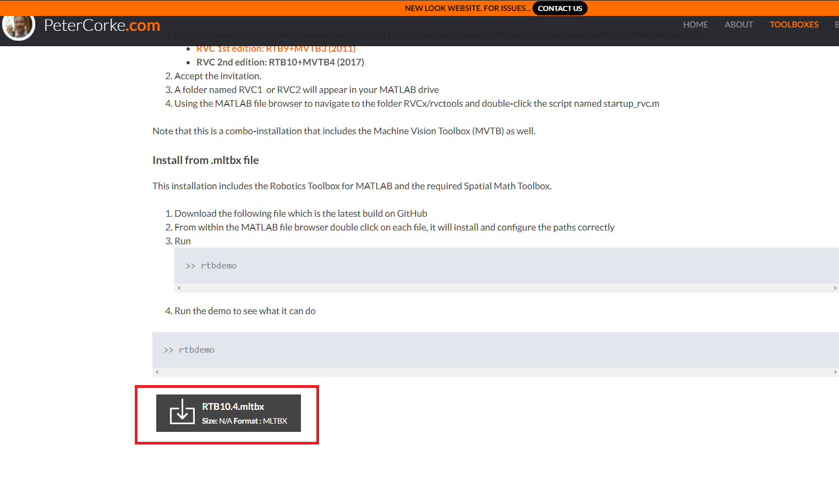

If you have difficulty with installation/setup, please let us know.

You can also run MATLAB through the ECF Machines. To do this, log into your ecf account: <https://ssl.ecf.utoronto.ca/ecf/services/login> and select **BA3114.** Note that there are only 30 machines and we have experienced some difficulty getting access to these computers, so we recommend that you run MATLAB on your own computers.